Conditional Formatting:
Is a Valuable tool used to visualize data to read trends and patterns.

EXPLAINATION OF THE CONDITIONAL FORMATTING:
1. To identify which products belong to the 'Fruit' category, I applied Conditional Formatting to the "Category" column (C2:C214). By setting a rule to highlight all cells containing the word "Fruit," the corresponding products are easily visible. This visual cue helps you to immediately distinguish fruit products from others in the dataset.

2. I used conditional formatting with data bars. This visually shows the range of amounts, where higher numbers are represented by longer bars and lower numbers by shorter bars. This approach makes it easy to compare the values at a glance, with the highest amounts having the longest bars and the lowest amounts having the shortest bars.
3. To identify which orders are from the "United States," I applied Conditional Formatting to the "Country" column (F2:F214). By setting a rule to highlight all cells containing "United States," the corresponding orders are easily visible. This visual cue helps you immediately distinguish orders from the United States from those from other countries in the dataset.
4. In the dataset, Conditional Formatting was applied to the "Amount" column (D2:D214) using Data Bars. Specifically, the top 10 amounts are highlighted with red data bars, visually representing the highest values in the dataset. This formatting allows for quick identification of the highest orders, making it easier to distinguish significant amounts at a glance.
By applying this formatting, the red data bars effectively highlight the top 10 amounts, providing a clear and immediate visual cue for identifying the largest orders.

Explanation on Pivot Table:
One-Dimensional Pivot Table:
A one-dimensional pivot table organizes data based on a single criterion or field. It typically shows data in rows or columns, summarizing information for just one variable.
Usage: It's used when you need to analyze data based on one aspect, such as counting the number of sales per product or summing amounts by country.
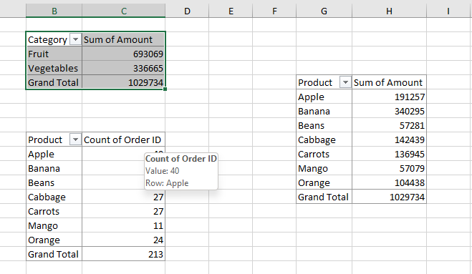

This image shows One dimensional Pivot Table.
Two-Dimensional Pivot Table:
A two-dimensional pivot table organizes data based on two criteria or fields. It displays data in both rows and columns, allowing for a more detailed analysis by comparing two variables simultaneously.
Usage: It's useful when you need to cross-tabulate data, such as comparing sales amounts across different products and countries.
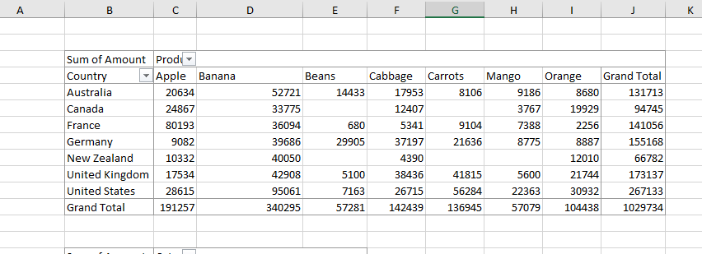

This image shows Two-dimensional Pivot Table.
Functions Applied on the Data:
1.Sum of Sales (Amount)
This formula adds up all the values in the Amount column to get the total sales amount.
2. Average of Total Sales:
This formula calculates the average of all the sales amounts by summing them up and dividing by the number of entries.
3. Minimum Sales (Min):
It identifies the smallest sales amount in the Amount column.
4. Maximum Sales (Max):
It identifies the largest sales amount in the Amount column.
5. Total Number of Orders (Total ID):
It counts the number of non-empty cells in the "Order ID" column, which gives the total number of orders.
6. Count of Fruits and Vegetables (COUNTIF):
It counts the number of times "Fruit" and "Vegetables" appear in the "Category" column.

